# Customer Management

**Customer Mgmt UI- Home Page**

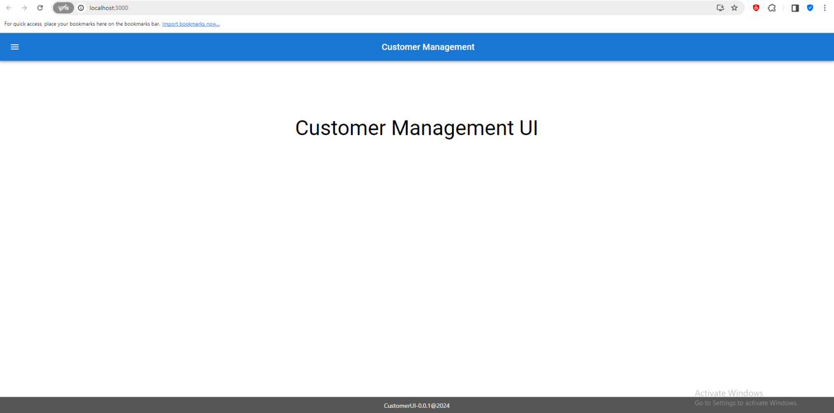

**Search Customer –Date Input Search**

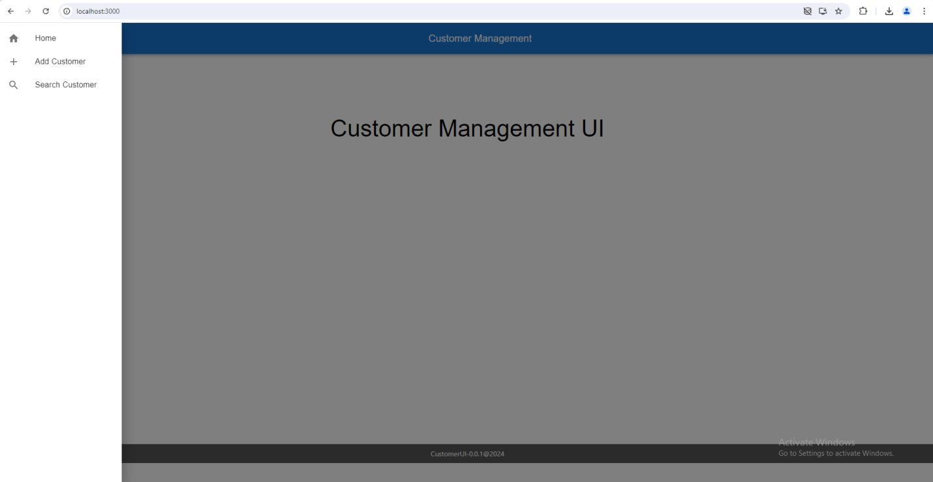

**Add Customer Page**

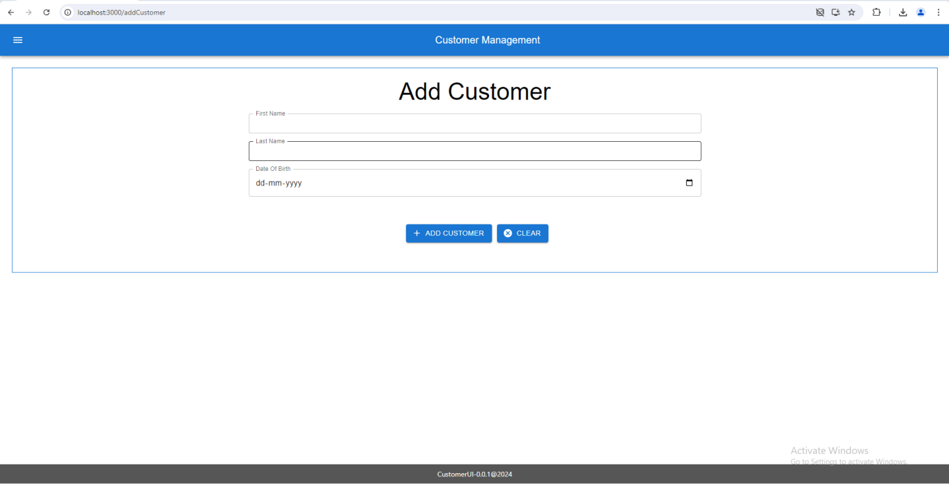

**Add Customer Input**

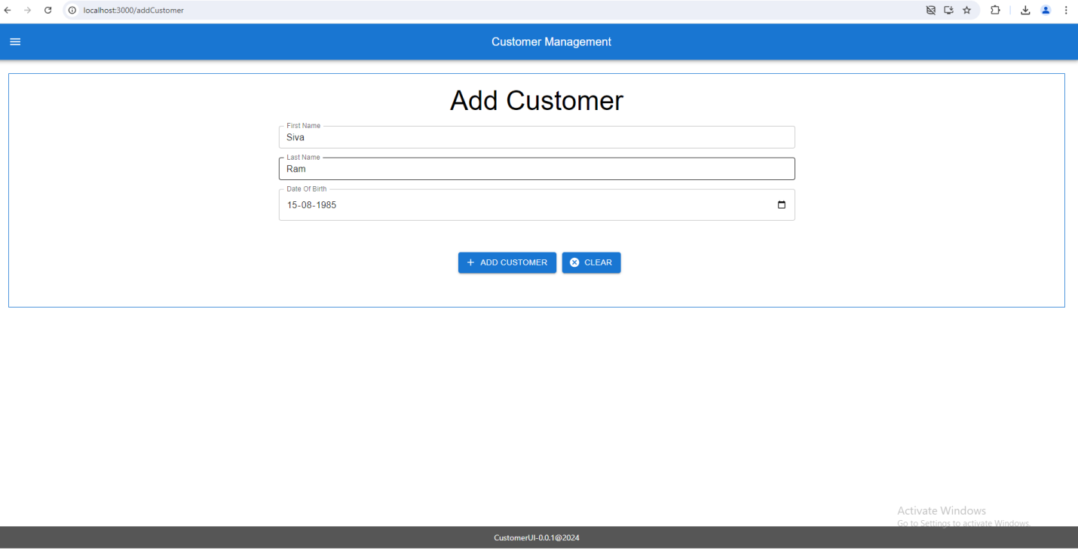

**Add Customer - Success**

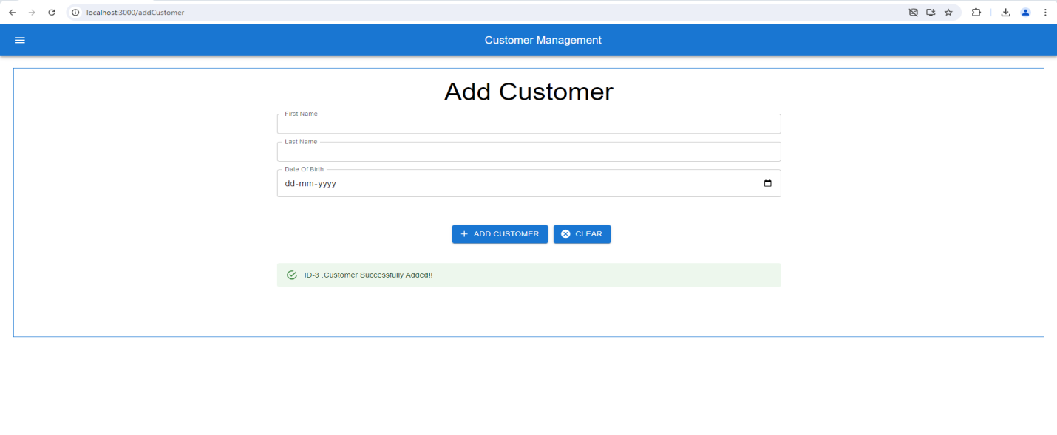

**Add Customer –Validation- Input data Already Exists**

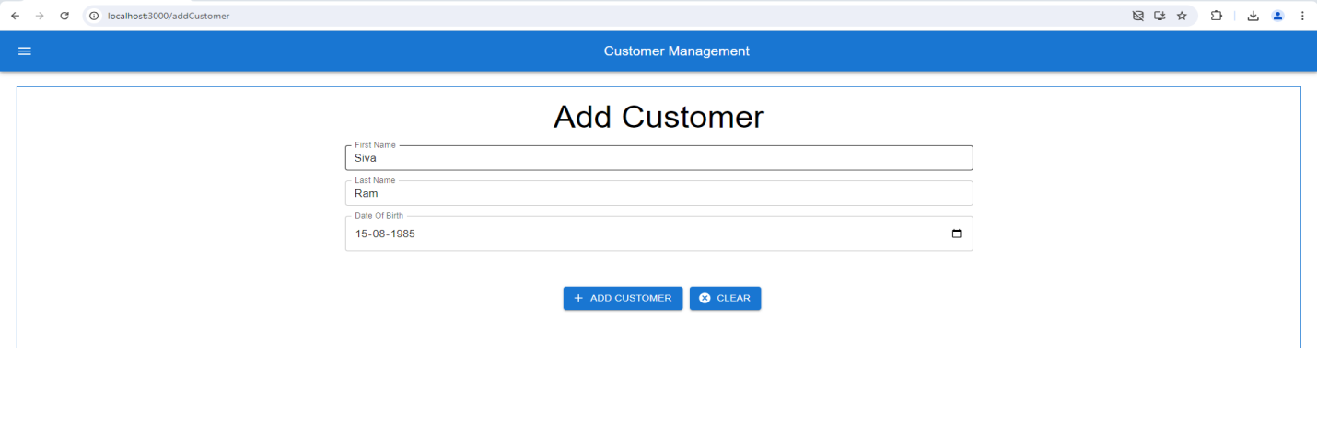

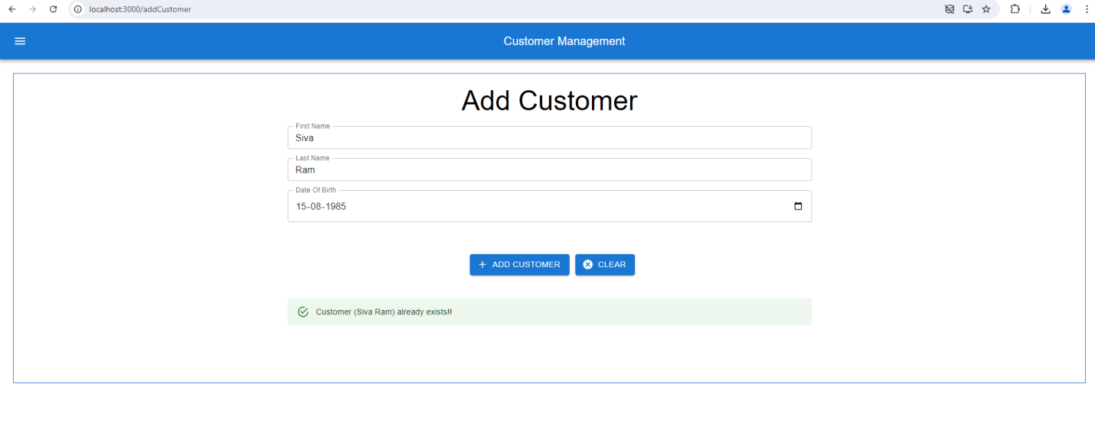

**Add Customer Input Null/EmptyValidation:**

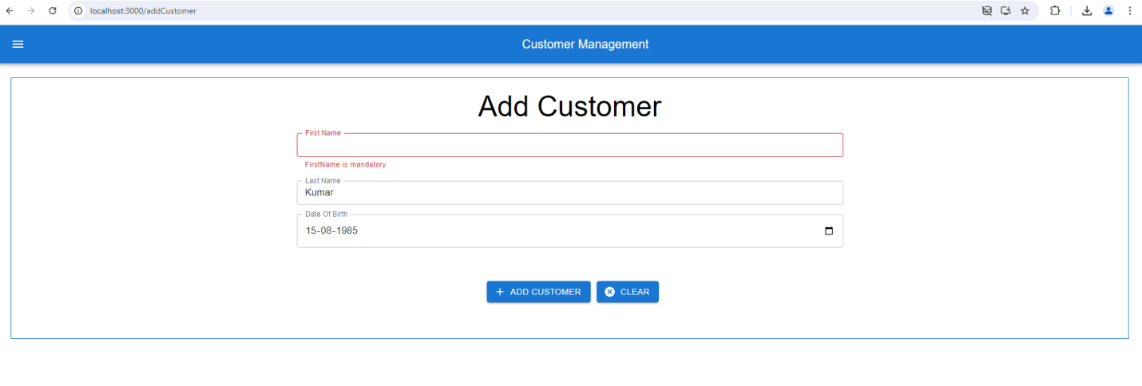

**Search Customer All/Default Search**

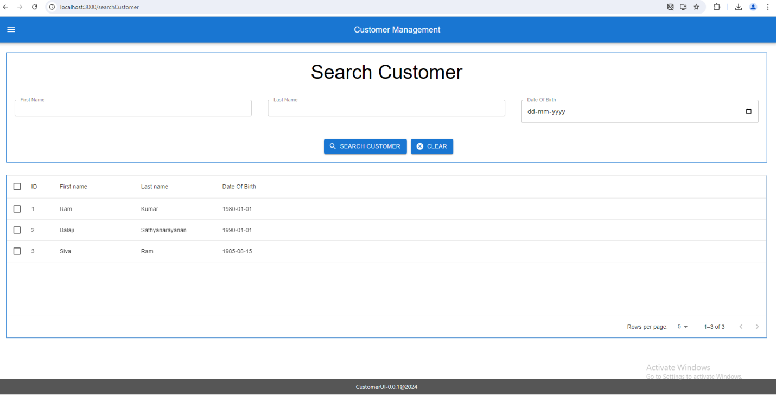

**Search Customer –First Name Input Search**

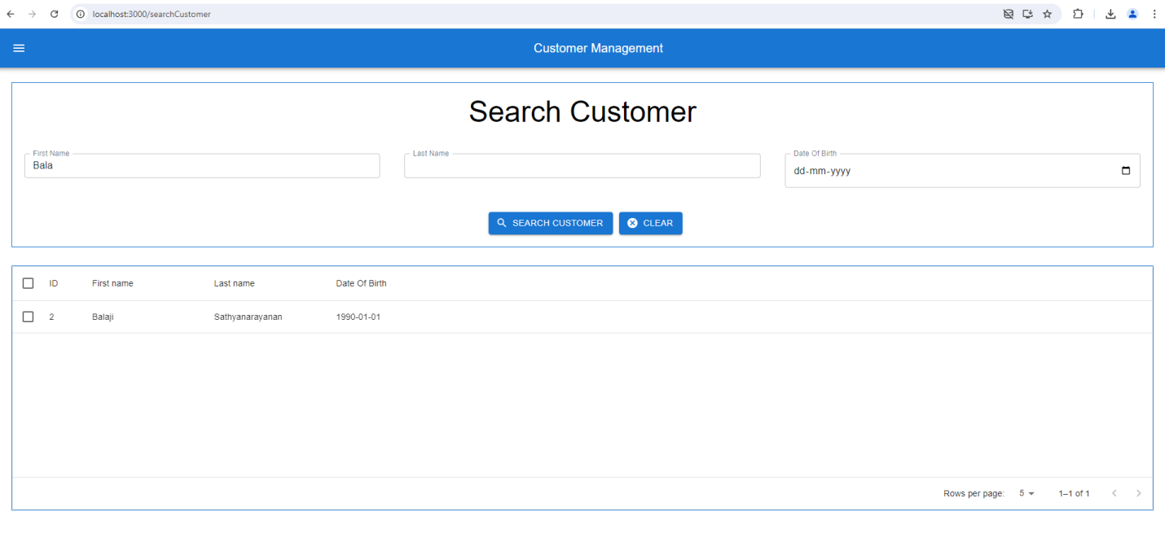

**Search Customer –Last Name Input Search**

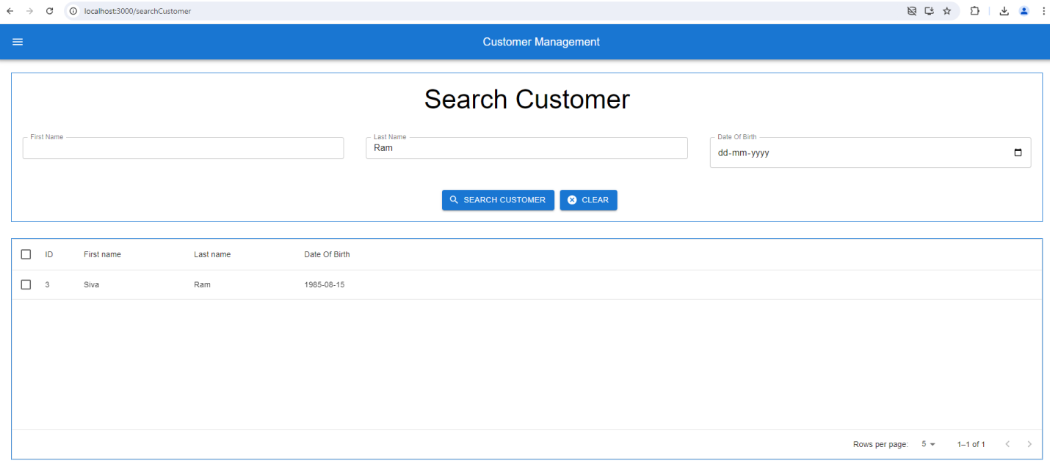

**Search Customer –Date Input Search**

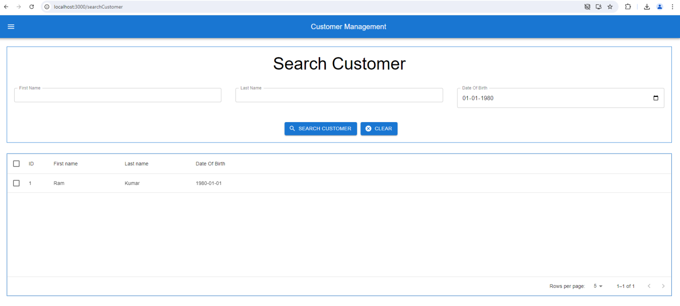

**Search Customer**

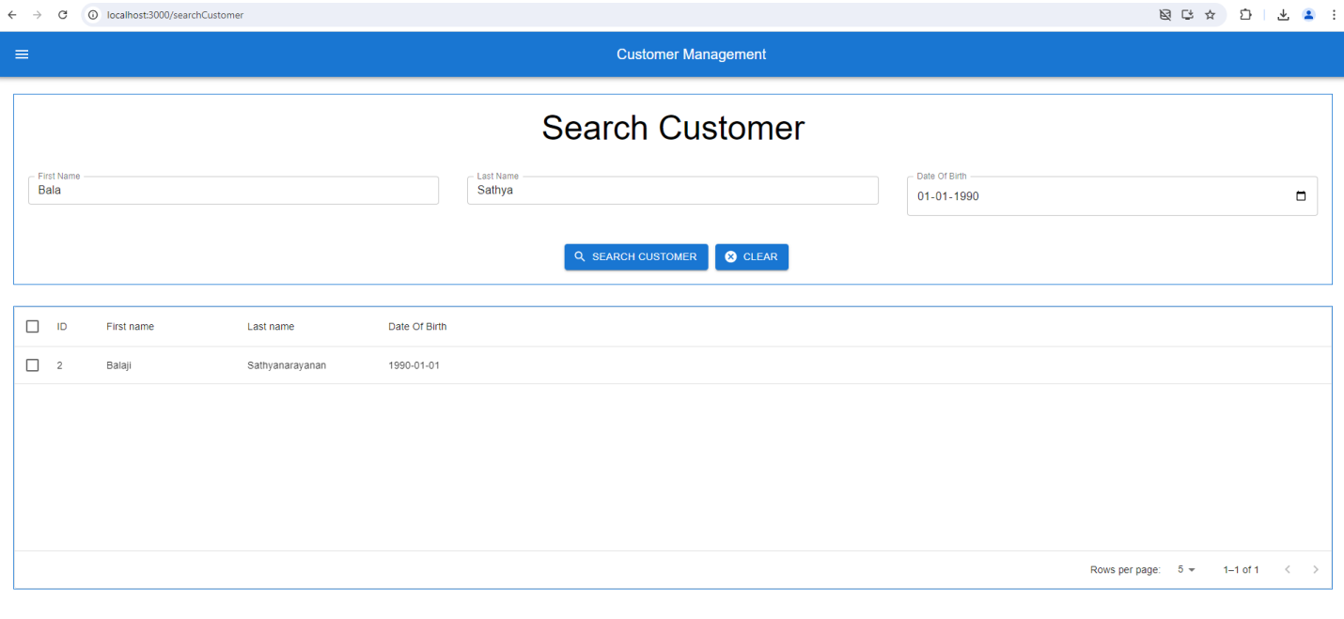

**Swagger – Customer Api:** [**http://localhost:8080/swagger-ui/**](http://localhost:8080/swagger-ui/)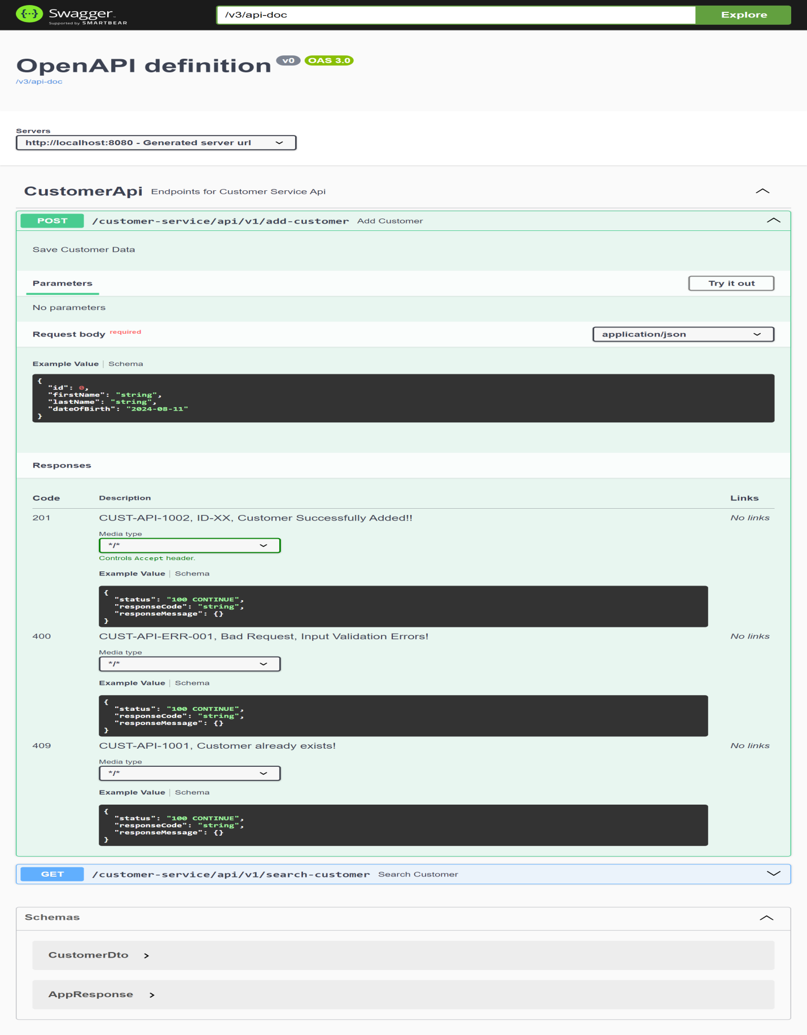

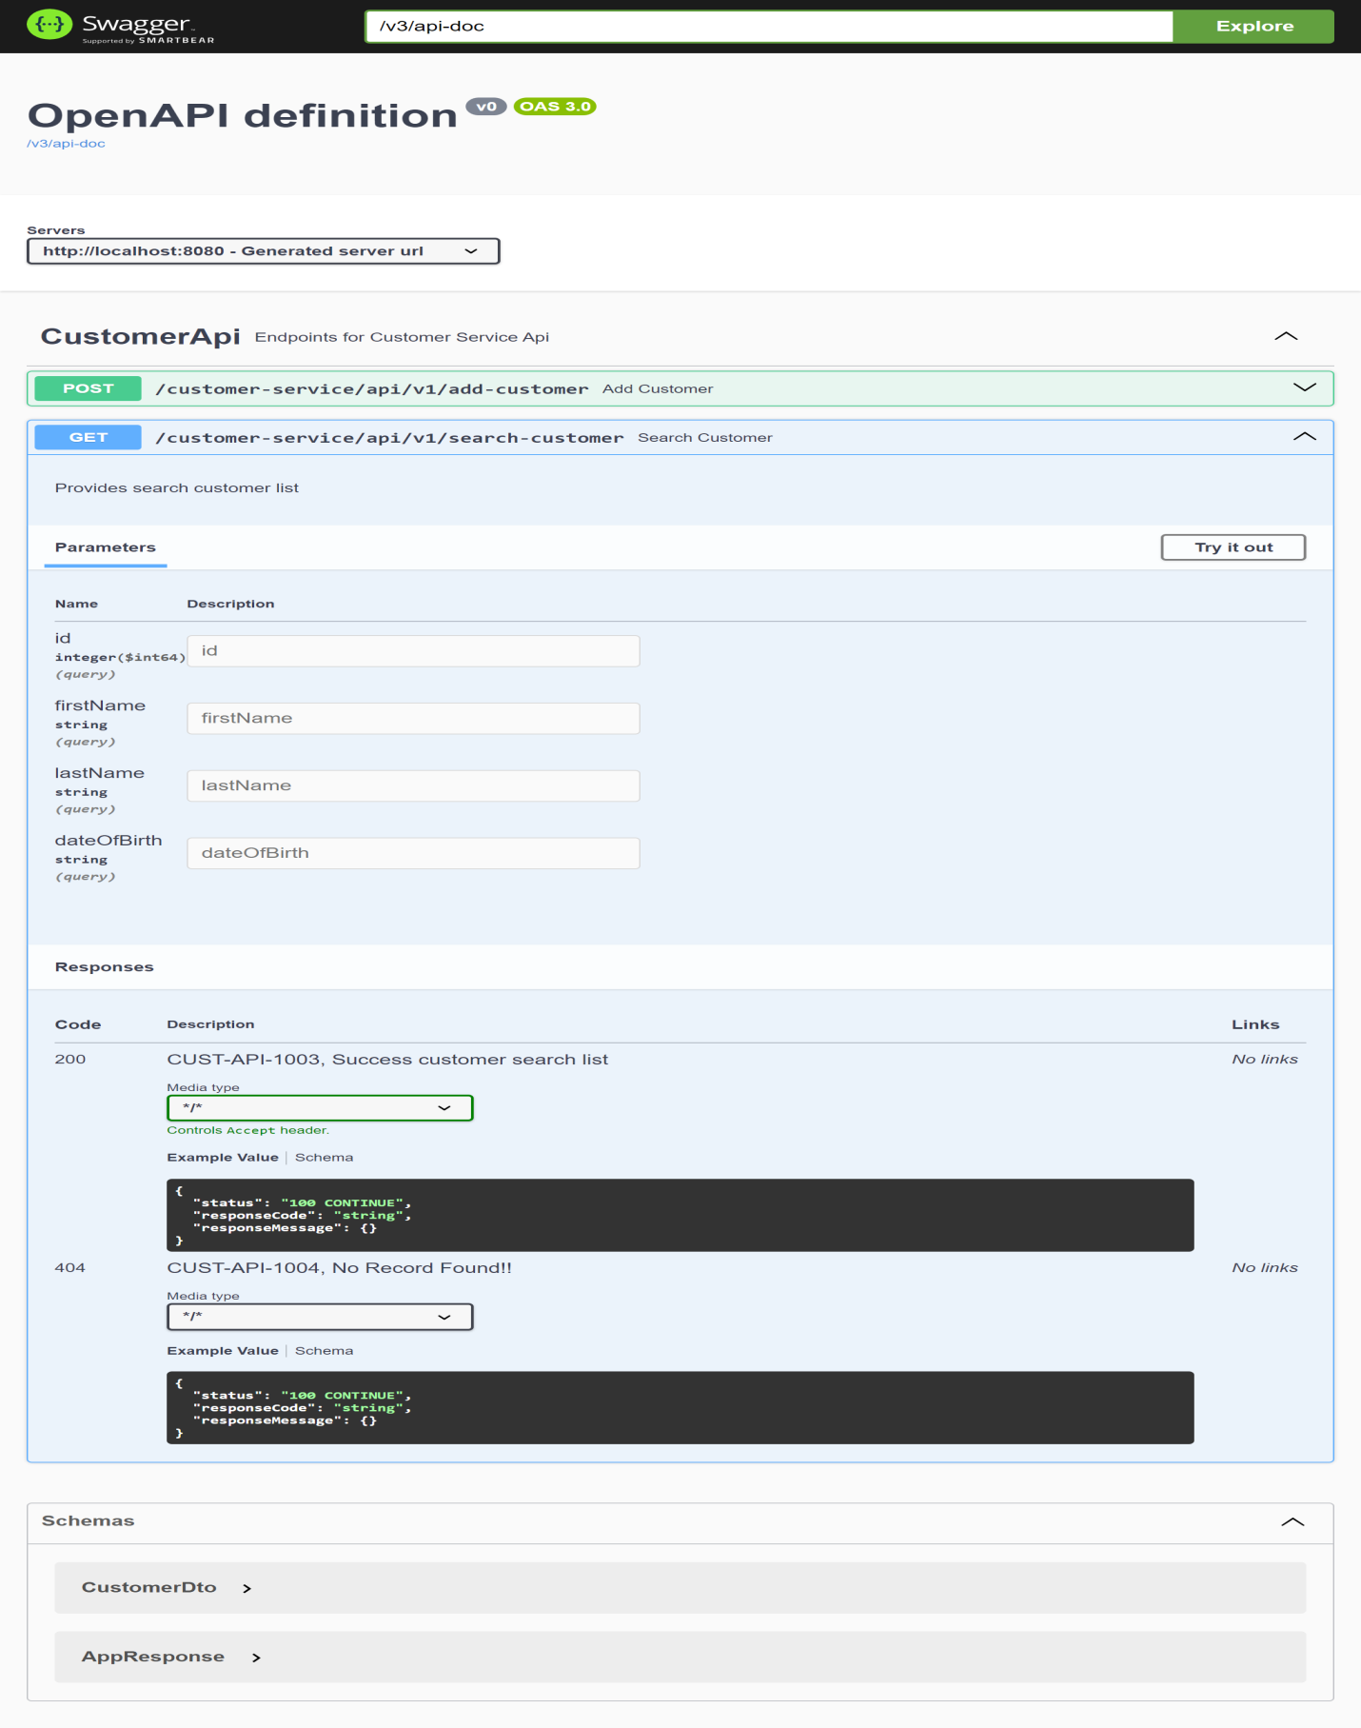

**Add Customer:**

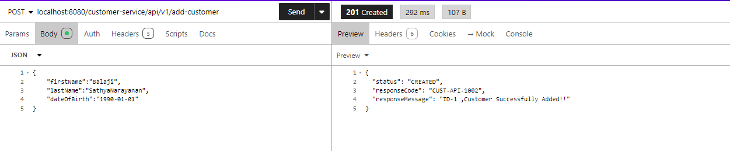

**Add Customer Already Exists:**

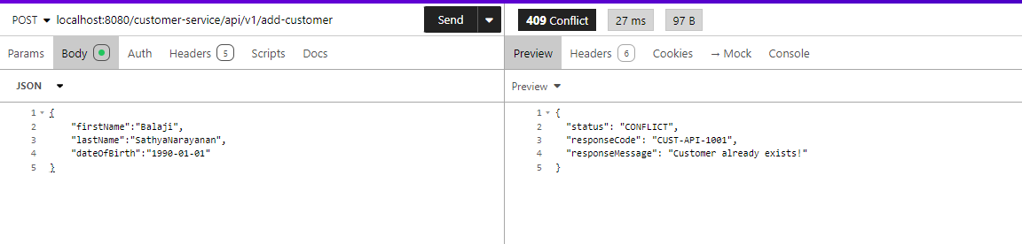

**Add Customer – Validation Fail:**

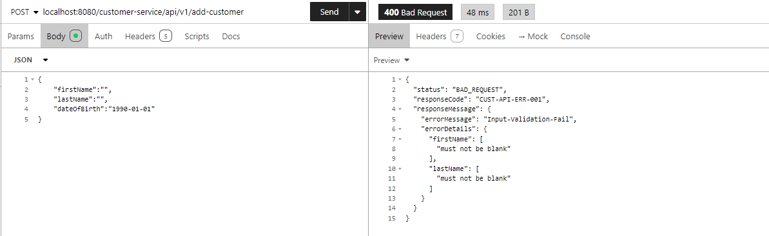

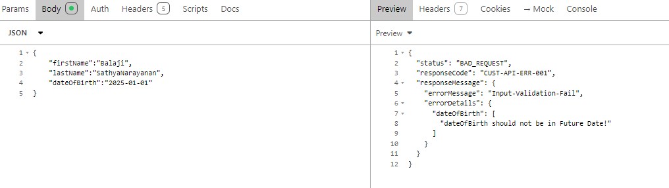

**Search Customer- All:**

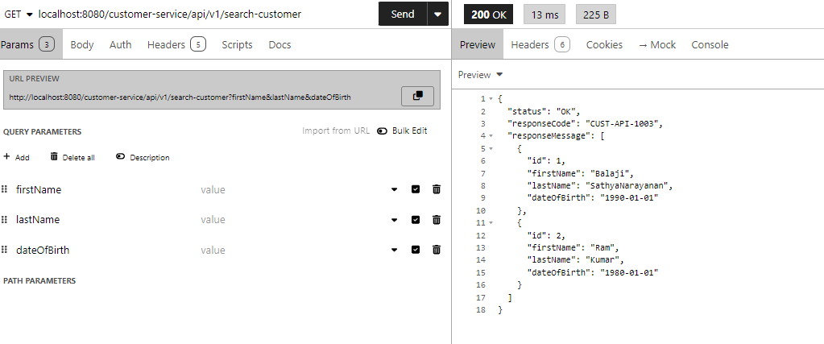

**Search Customer with query params - with Input fields:**

